**Integrating the Healthcare Enterprise**



**IHE ITI**

**Technical Framework Supplement**

**Patient Identity Management using FHIR**

**PIMuF**

*<For FHIR based profiles, indicate the FHIR release & the FMM levels of the contents. Delete otherwise.>*

HL7® FHIR® STU x

Using Resources at FMM Level n-n

**Revision 0.1 – Draft in Preparation for Public Comment (*or* Trial Implementation)**

*<The IHE Documentation Specialist will change the title to just “Draft for Public Comment” or “Trial Implementation” upon publication. Leave “as is” until then.>*

Date: <Month xx, 20xx>

Author: ITI Technical Committee

Email: <domain_name@ihe.net>

**Please verify you have the most recent version of this document.** See [here](http://ihe.net/Technical_Frameworks/) for Trial Implementation and Final Text versions and [here](http://ihe.net/Public_Comment/) for Public Comment versions.

*<Instructions to authors are encapsulated in angled brackets as “< … >” and denoted with italicized text. These instructions should be deleted entirely prior to publication.>*

*<Use of capitalization: Please follow standard English grammar rules-only proper nouns and names are upper case. For example, “Modality Actor” is upper case, but “an actor which fulfills the role of a modality” is lower case. Do not use upper case to emphasize a word/topic. Examples:*

*<Note: Before creating a draft supplement, please review the editing conventions, which include information such as section, table and diagram numbering and how to use Microsoft Word tools, at* [*http://wiki.ihe.net/index.php?title=Writing_Technical_Frameworks_and_Supplements*](http://wiki.ihe.net/index.php?title=Writing_Technical_Frameworks_and_Supplements)*. This guidance is especially useful for first time authors.>*

*<This supplement template is intended for developing new profiles or making significant changes to profiles, such as adding formal options. Simple changes to existing supplements or profiles should be made using the Change Proposal (CP) process. See the Technical Framework Development section at* [*http://wiki.ihe.net/index.php?title=Process#Technical_Framework_Development*](http://wiki.ihe.net/index.php?title=Process#Technical_Framework_Development) *for more guidance on supplements vs. CPs.>*

*<All of the sections in this document are required. Sections may not be deleted. The outline numbering is intended to be consistent across profiles and across domains, so do not adjust the outline numbering. If there is no relevant content for a section, simply state “Section not applicable”, but leave the numbering intact. Sub-sections may be added for clarity.>*

*<This supplement template includes templates for Volumes 1 (Profiles), 2 (Transactions), 3 (Content Modules), and 4 (National Extensions).>*

*<Volumes 1, 2, and/or 3 are developed together for Public Comment and Trial Implementation submission. Volume 4, National Extensions, is typically developed at a later point in time, usually at Trial Implementation or later. Templates for all four volumes are included in this document for the sake of completeness. If you are beginning a new profile, you are strongly discouraged from using National Extensions and should instead focus on optional data sets or other alternatives. For more information, see* [*http://wiki.ihe.net/index.php?title=National_Extensions_Process*](http://wiki.ihe.net/index.php?title=National_Extensions_Process)*.>*

**Foreword**

This is a supplement to the IHE ITI Technical Framework <VX.X>. Each supplement undergoes a process of public comment and trial implementation before being incorporated into the volumes of the Technical Frameworks.

*<For Public Comment:>* This supplement is published on <Month XX, 201x> for Public Comment. Comments are invited and can be submitted at <http://www.ihe.net/Public_Comment/#domainname>. In order to be considered in development of the Trial Implementation version of the supplement, comments must be received by <Month XX, 201X>.

*<For Trial Implementation:>* This supplement is published on <Month XX, 201X> for Trial Implementation and may be available for testing at subsequent IHE Connectathons. The supplement may be amended based on the results of testing. Following successful testing it will be incorporated into the <Domain Name> Technical Framework. Comments are invited and can be submitted at <http://www.ihe.net/Public_Comment/#domainname>.

This supplement describes changes to the existing technical framework documents.

“Boxed” instructions like the sample below indicate to the Volume Editor how to integrate the relevant section(s) into the relevant Technical Framework volume.

*Amend section X.X by the following:*

Where the amendment adds text, make the added text **bold underline**. Where the amendment removes text, make the removed text **~~bold strikethrough~~**. When entire new sections are added, introduce with editor’s instructions to “add new text” or similar, which for readability are not bolded or underlined.

General information about IHE can be found at [www.ihe.net](http://www.ihe.net/).

Information about the IHE <Domain Name> domain can be found at [ihe.net/IHE_Domains](http://ihe.net/IHE_Domains/).

Information about the organization of IHE Technical Frameworks and Supplements and the process used to create them can be found at [http://ihe.net/IHE_Process](http://ihe.net/IHE_Process/) and [http://ihe.net/Profiles](http://ihe.net/Profiles/).

The current version of the IHE <Domain name>Technical Framework can be found at [http://ihe.net/Technical_Frameworks](http://ihe.net/Technical_Frameworks/).

*<Comments may be submitted on IHE Technical Framework templates any time at* [*http://ihe.net/Templates_Public_Comments*](http://ihe.net/Templates_Public_Comments/)*. Please enter comments/issues as soon as they are found. Do not wait until a future review cycle is announced.>*

**CONTENTS**

**Introduction to this Supplement** **9**

Open Issues and Questions 11

Closed Issues 11

General Introduction and Shared Appendices **12**

Appendix A – Actor Summary Definitions **12**

Appendix B – Transaction Summary Definitions **12**

Appendix D – Glossary **13**

<Copyright Licenses> 14

<Domain-specific additions> 14

X <Profile Name (Acronym)> Profile **15**

X.1 <Profile Acronym> Actors, Transactions, and Content Modules 15

X.1.1 Actor Descriptions and Actor Profile Requirements 18

X.1.1.1 <Actor A> 19

X.1.1.2 <Actor B> 19

X.2 <Profile Acronym> Actor Options 19

X.2.1 <Option Name> 21

X.3 <Profile Acronym> Required Actor Groupings 21

X.4 <Profile Acronym> Overview 24

X.4.1 Concepts 24

X.4.2 Use Cases 25

X.4.2.1 Use Case #1: <simple name> 25

X.4.2.1.1 <simple name> Use Case Description 25

X.4.2.1.2 <simple name> Process Flow 25

X.5 <Profile Acronym> Security Considerations 27

X.6 <Profile Acronym> Cross Profile Considerations 28

Appendix A – <Appendix Title> **30**

A.1 <Title> 30

A.1.1 <Title> 30

Appendix B – <Appendix Title> **31**

B.1 <Title> 31

B.1.1 <Title> 31

3.Y <Transaction Name [Domain Acronym-#]> 32

3.Y.1 Scope 32

3.Y.2 Actor Roles 32

3.Y.3 Referenced Standards 33

3.Y.4 Interaction Diagram 33

3.Y.4.1 <Message 1 Name> 34

3.Y.4.1.1 Trigger Events 34

3.Y.4.1.2 Message Semantics 34

3.Y.4.1.3 Expected Actions 35

3.Y.4.2 <Message 2 Name> 35

3.Y.4.2.1 Trigger Events 35

3.Y.4.2.2 Message Semantics 35

3.Y.4.2.3 Expected Actions 36

3.Y.5 Protocol Requirements 36

3.Y.6 Security Considerations 36

3.Y.6.1 Security Audit Considerations 36

3.Y.6.(z) <Actor> Specific Security Considerations 36

Appendix A – <Appendix Title> **38**

A.1 <Title> 38

A.1.1 <Title> 38

Appendix B – <Appendix Title> **39**

B.1 <Title> 39

B.1.1 <Title> 39

Volume 2 Namespace Additions **40**

5 IHE Namespaces, Concept Domains and Vocabularies **42**

5.1 IHE Namespaces 42

5.2 IHE Concept Domains 42

5.3 IHE Format Codes and Vocabularies 43

5.3.1 IHE Format Codes 43

5.3.2 IHEActCode Vocabulary 43

5.3.3 IHERoleCode Vocabulary 44

6 Content Modules **45**

6.3.1 CDA Document Content Modules 45

6.3.1.D <Content Module Name (Acronym)> Document Content Module 46

6.3.1.D.1 Format Code 46

6.3.1.D.2 Parent Template 46

6.3.1.D.3 Referenced Standards 46

6.3.1.D.4 Data Element Requirement Mappings to CDA 47

6.3.1.D.5 <Content Module Name (Acronym, if applicable)> Document Content Module Specification 48

6.3.1.D.5.1 <Header Element or Section Name> <Vocabulary Constraint or Condition> 50

6.3.1.D.5.2 <Header Element or Section Name> <Vocabulary Constraint or Condition> 50

6.3.1.D.5.3 <Header Element or Section Name> <Vocabulary Constraint or Condition> 51

6.3.1.D.5.4 <Header Element or Section Name> <Vocabulary Constraint or Condition> 51

6.3.1.D.5.5 <Template Title name> <Vocabulary Constraint or Condition> 53

6.3.1.D.5.6 <Template Title name> <Vocabulary Constraint or Condition> 54

6.3.1.D.6 <Document and Acronym Name> Conformance and Example 54

6.3.2 CDA Header Content Modules 55

6.3.2.H <Header Element Module Name> Header Content Module 55

6.3.2.H.1 <Description Name> <e.g., Responsible Party> <Specification Document or Vocabulary Constraint> 56

6.3.2.H.2 <Description Name> <Specification Document OR Vocabulary Constraint> 57

6.3.2.H.3 <Description Name> <Specification Document OR Vocabulary Constraint> 57

6.3.3 CDA Section Content Modules 58

6.3.3.10.S <Section Module Name> - Section Content Module 59

6.3.3.10.S.1 <Data Element or Section Name> <Condition, Specification Document, or Vocabulary Constraint> 60

6.3.3.10.S.2 <Data Element or Section Name> <Condition, Specification Document, or Vocabulary Constraint> 60

6.3.3.10.S.3 <Data Element or Section Name> <Condition, Specification Document, or Vocabulary Constraint> 61

6.3.3.10.S Medical History - Cardiac Section 11329-0 61

6.3.4 CDA Entry Content Modules 63

6.3.4.E <Entry Content Module Name> Entry Content Module 64

6.3.4.E.1 Simple Observation (wall motion) Vocabulary Constraints 65

6.3.4.E.2 Simple Observation (wall morphology) Constraints 66

<e.g.,6.3.4.E Result Observation - Cardiac 67

6.4 Section not applicable 69

6.5 <Domain Acronym> Value Sets and Concept Domains 69

6.5.x <Value Set Name/Concept Domain Name> <oid> 69

<e.g.,6.5.1 Drug Classes Used in Cardiac Procedure 1.3.6.1.4.1.19376.1.4.1.5.15 70

6.5.1 UV_CardiacProcedureDrugClasses 70

Appendix A – <Appendix Title> **73**

A.1 <Title> 73

A.1.1 <Title> 73

Appendix B – <Appendix Title> **74**

B.1 <Title> 74

B.1.1 <Title> 74

4 National Extensions **75**

4.I.2.1.1 US_CardiacProcedureDrugClasses (1.3.6.1.4.1.19376.1.4.1.5.15) 76

Appendix A – <Appendix Title> **78**

A.1 <Title> 78

A.1.1 <Title> 78

Appendix B – <Appendix Title> **79**

B.1 <Title> 79

B.1.1 <Title> 79

# Introduction to this Supplement

Whenever possible, IHE profiles are based on established and stable underlying standards. However, if an IHE committee determines that an emerging standard offers significant benefits for the use cases it is attempting to address and has a high likelihood of industry adoption, it may develop IHE profiles and related specifications based on such a standard.

The IHE committee will take care to update and republish the IHE profile in question as the underlying standard evolves. Updates to the profile or its underlying standards may necessitate changes to product implementations and site deployments in order for them to remain interoperable and conformant with the profile in question.

This <profile acronym> Profile (or This Technical Framework Supplement) uses the emerging HL7® FHIR® specification. The FHIR release profiled in this supplement is STU <x>. HL7 describes the STU (Standard for Trial Use) standardization state at https://www.hl7.org/fhir/versions.html.

In addition, HL7 provides a rating of the maturity of FHIR content based on the FHIR Maturity Model (FMM): level 0 (draft) through 5 (normative ballot ready). The FHIR Maturity Model is described at http://hl7.org/fhir/versions.html#maturity.

Key FHIR STU <x> content, such as Resources or ValueSets, used in this profile, and their FMM levels are:

|  |  |
| --- | --- |
| FHIR Content  (Resources, ValueSets, etc. | FMM Level |
| Patient | 5 |
|  |  |

Provides the means for FHIR systems (and their users) to operate in an environment where multiple patient registration domains co-exist.  
(Expand an existing Profile or create a new one) To define interoperable interactions for the FHIR-based exchanges to fully enable consistent cross-domain patient identity management across multiple patient registration domains for a client registry (CR) and/or enterprise master patient index (EMPI) solutions.

Functionality:

* New patient is created
* Patient information updates
* Subscribe to all patient information updated [new functionality: Consumer->PIX->Consumer]
  + Only when Identifiers changes
  + All changes
  + Limited subset of ID domains.
* Reconciled duplicates Merged
* Linked
* Un-Linked
* Deprecate or delete Patient

## Open Issues and Questions

1. HL7 Patient Administration workgroup is looking at better defining the patient merge/link functionality in FHIR, and may not align well with our profile, and may not be adopted by our users. There could be eventually two distinct solutions to the same problem.

## Closed Issues

# General Introduction and Shared Appendices

The [IHE Technical Framework General Introduction and Shared Appendices](http://ihe.net/Technical_Frameworks/#GenIntro) are components shared by all of the IHE domain technical frameworks. Each technical framework volume contains links to these documents where appropriate.

*Update the following appendices to the General Introduction as indicated below. Note that these are* ***not*** *appendices to Volume 1.*

# Appendix A – Actor Summary Definitions

*Add the following actors to the IHE Technical Frameworks General Introduction Appendix A:*

|  |  |
| --- | --- |
| Actor Name | Definition |
| Patient Identity  Manager | Provides cross-referencing of patient identifiers across Patient Identifier Domains.  Provides a searchable repository of patient demographic  information.  Receives patient identity events related to patient identification from patient identity sources actors.  Sends all events related to patient identification (creation, update, merge, link, etc.) to maintain patient identification across systems. |
| Patient Subscriber | Receives notifications about events impacting patient identification (creation, update, merge, link, etc.).  Sends subscription requests for Patient Identity events and updates. |
| Patient Identity Consumer | Receives patient identity events related to patient identification. |

# Appendix B – Transaction Summary Definitions

*Add the following transactions to the IHE Technical Frameworks General Introduction Appendix B:*

*<After determining that a suitable transaction does not already exist, please note that the “verb-noun” construction for transaction names is preferred were possible. For additional guidance, see the IHE wiki at* [*http://wiki.ihe.net/index.php/IHE_Profile_Design_Principles_and_Conventions#Transactions*](http://wiki.ihe.net/index.php/IHE_Profile_Design_Principles_and_Conventions#Transactions)*.*

|  |  |
| --- | --- |
| Transaction Name and Number | Definition |
| Mobile Patient Identity Feed [ITI-XX] | Allows to notify the receiving actor of all events related to patient identification (creation, update, merge, link, etc.). |
| Subscribe to Patient Updates [ITI-X1] | Allow the subscription to notifications about events impacting patient identification (creation, update, merge, link, etc.). |
| Patient Update Notification [ITI-X2] | Allows a Patient Subscriber to be receive notifications from the Patient Identity Manager Actor about the events impacting patient identification (creation, update, merge, link, etc.) and corresponding to the corresponding subscription. |

# Appendix D – Glossary

*Add the following* ***new*** *glossary terms to the IHE Technical Frameworks General Introduction Appendix D.*

*<Add any* ***new glossary additions*** *associated with the profile here.* *Verify that any glossary terms added here are not already contained in the* [*IHE Glossary*](http://ihe.net/Technical_Frameworks/#GenIntro)*. Also, please review the* [*Glossary Rules*](http://wiki.ihe.net/index.php/Official_Templates#Glossary_Rules) *for terms that should/should not be added to the IHE Glossary>*

|  |  |
| --- | --- |
| Glossary Term | Definition |
|  |  |
|  |  |
|  |  |
|  |  |

*<Note: The sections following this Introduction will eventually be added as Final Text to Volumes 1 – 4 of the Technical Framework. The material above this note (the Introduction to this Supplement, Open and Closed Issues and General Introduction and Shared Appendices sections) will be deleted when this supplement is moved to Final Text.>*

**Volume 1 – Profiles**

## <*Copyright Licenses>*

*<General copyright licenses and permissions are listed in the IHE Technical Frameworks* *General Introduction. Add information on any standards referenced in the profile that are not already addressed in the* [*General Introduction*](http://ihe.net/Technical_Frameworks/#GenIntro) *(see Section 9.0).>*

## <*Domain-specific additions>*

*<Some domains have specific sections, added as subsections to Sections 1 or 2, in their Technical Frameworks. These types of additions are allowed as long as they do not adjust the overall numbering scheme which needs to remain consistent across domains. If there are such additions, they should be included here; if none enter NA.>*

*Add new Section #*

# X Patient Identity Management using FHIR (PIMuF) Profile

The Patient Identity Management using FHIR (PIMuF) Profile supports the creating, updating and deprecating of demographic information about a subject of care using the HL7 FHIR standard and its RESTful transactions. Beyond the basic create, retrieve, update and delete (CRUD) transaction set, this profile addresses important patient safety issues related to the merging of two patient demographic records that have, in error, been established for the same person. Leveraging the Profile’s actors and the architectural patterns that describe their operation PIMuF supports patient-safe demographic records merging by stipulating the mandatory behaviours of FHIR servers that maintain health data about the subjects of care such that no health information is “orphaned” following a merge.

## X.1 PIMuF Actors, Transactions, and Content Modules

This section defines the actors, transactions, and/or content modules in this profile. General definitions of actors are given in the Technical Frameworks General Introduction Appendix A. IHE Transactions can be found in the Technical Frameworks General Introduction Appendix B. Both appendices are located at <http://ihe.net/Technical_Frameworks/#GenIntro>

Figure X.1-1 shows the actors directly involved in the PIMuF Profile and the relevant transactions between them. If needed for context, other actors that may be indirectly involved due to their participation in other related profiles are shown in dotted lines. Actors which have a required grouping are shown in conjoined boxes (see Section X.3).

Profile Acronym: Actor C

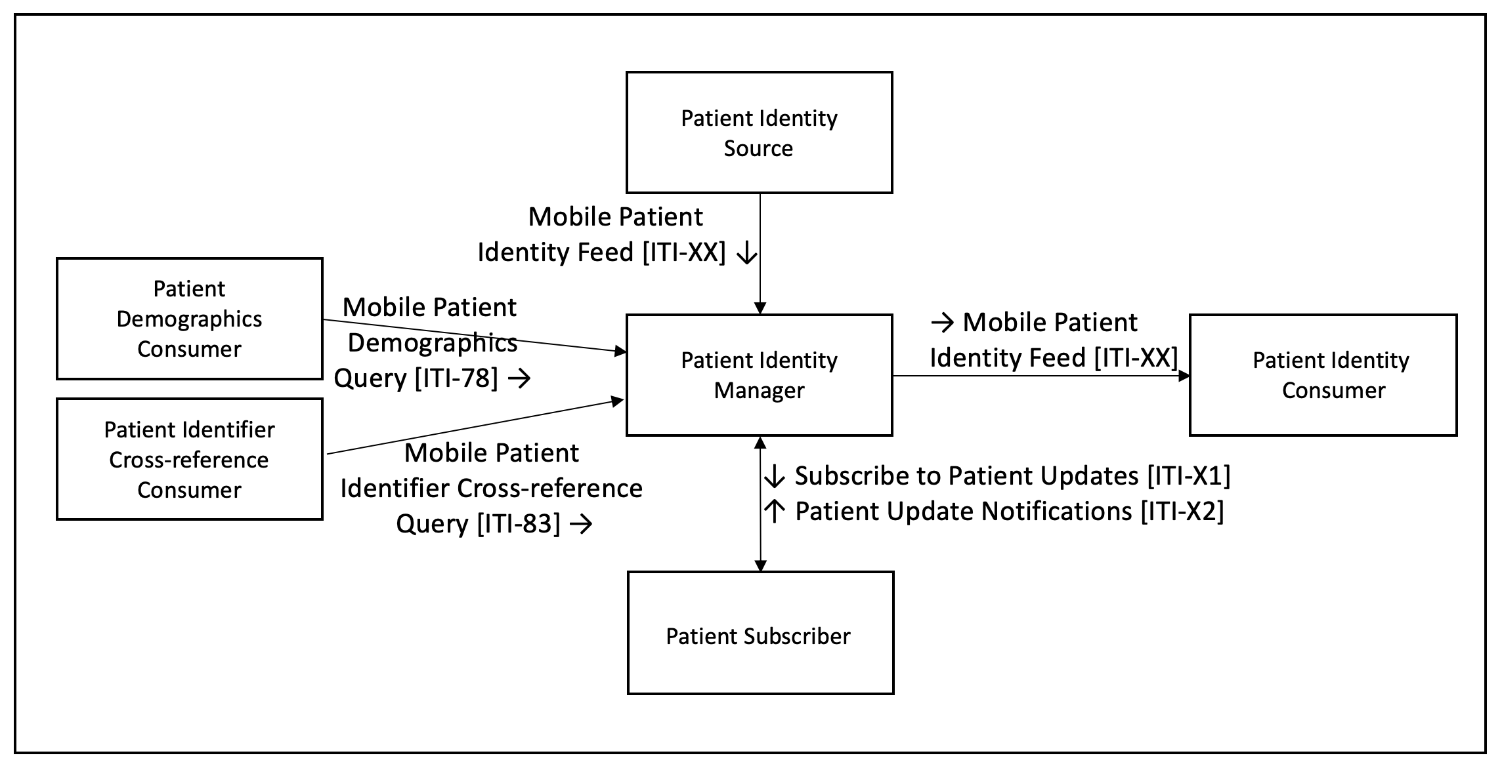

**Figure X.1-1:PIMuF Actor Diagram**

Table X.1-1 lists the transactions for each actor directly involved in the PIMuF Profile. To claim compliance with this profile, an actor shall support all required transactions (labeled “R”) and may support the optional transactions (labeled “O”).

**Table X.1-1: PIMuF Profile - Actors and Transactions**

|  |  |  |  |  |
| --- | --- | --- | --- | --- |
| Actors | Transactions | Initiator or Responder | Optionality | Reference |
| Patient Identity Source | Mobile Patient Identity Feed [ITI-XX] | I | R |  |
| Patient Identity Consumer | Mobile Patient Identity Feed [ITI-XX] | R | R |  |
| Patient Identity Manager | Mobile Patient Identity Feed [ITI-XX] | I | R |  |
| Mobile Patient Identity Feed [ITI-XX] | R | R |  |
| Mobile Patient Identifier Cross-reference Query [ITI-83] | R | R | TF 2: 3.83 |
| Mobile Patient Demographics Query [ITI-78] | R | R | TF 2: 3.78 |
| Subscribe to Patient Updates [ITI-X1] | R | O ( See Note 1) | X.2.1 |
| Patient Update Notification [ITI-X2] | I | O ( See Note 1) | X.2.1 |
| Patient demographics Consumer | Mobile Patient Demographics Query [ITI-78] | I | O | TF 2: 3.83 |
| Patient Identifier Cross-reference Consumer | Mobile Patient Identifier Cross-reference Query [ITI-83] | I | O | TF 2: 3.83 |
|  | Subscribe to Patient Updates [ITI-X1] | I | R |  |
| Patient Subscriber | Patient Update Notification [ITI-X2] | R | R |  |

Note 1: Required if the Subscription option declared.

### X.1.1 Actor Descriptions and Actor Profile Requirements

*<****Do not repeat*** *the definitions of the actors that are maintained in the* [*TF General Introduction Appendix A*](http://ihe.net/Technical_Frameworks/#GenIntro) *(Actors). Include text in this section to describe the actor in the context of this profile.>*

*<****This section is empty unless there is a need for specific descriptions or requirements. Actors without additional requirements or elaborate descriptions need not be listed here.*** *>*

*<This section may also define system behavior. For example, in the PIX Profile, an ADT message is first received by the PIX Manager. The PIX Manager should then use this data to respond to subsequent queries. Although this may be implied, it should be explicitly documented in this section.>*

#### X.1.1.1 Patient Identity Manager

A Patient Identity Manager can receive patient update notifications and updates from Patient Identity Sources, the Patient Identity Manager also sends patient notifications and updates for Patients identity changes as a Patient Identity Source.

A Subscription Manager can receive subscription requests and send notifications of any updates to Patients Demographics or identifiers.

#### X.1.1.2 Patient Identity Consumer

A Patient Subscriber can send subscription requests and receive notifications for updates to any specified Patients Demographics or identifiers.

#### X.1.1.3 Patient Subscriber

Could probably be omitted here.

#### X.1.1.4 Patient demographics Consumer

Explain why they are in this profile (patient identity manager vs demographics supplier)

#### X.1.1.5 Patient Identifier Cross-reference Consumer

Explain why they are in this profile (patient identity manager vs cross-reference manager)

## X.2 PIMuF Actor Options

*<Modify the following table, listing all the actors in this profile, the options available for each, and references to sections that state requirements for compliance to each option. For actors with no options, state “No options defined” in column 2.>*

*<Note: Options are directly carried over to the integration statements which are published by vendors for review by buyers. Too many options can be confusing for readers, so try to* ***minimize*** *options for actors and only use if necessary.>*

*<Several options for Content Consumers are defined in PCC TF-2: 3.1.1-3.1.4. It is recommended that these options are reused, if applicable, but read the option definitions thoroughly to be certain that they apply. If they do not apply in their entirety, you will need to define a corresponding option in this profile. The recommended naming convention for a similar, but different, option is, for example, “View Option - <profile acronym>, etc., “View Option – CIRC”.>*

**Options tha**t may be selected for each actor in this profile, if any, are listed in the Table X.2-1. Dependencies between options, when applicable, are specified in notes.

**Table X.2-1:PIMuF – Actors and Options**

|  |  |  |
| --- | --- | --- |
| Actor | Option Name | Reference |
| Patient Identity Source | None |  |
| Patient Identity Consumer | None |  |
| Patient Identity Manager | Subscription | Section X.2.1 |
| Patient Subscriber | None |  |
| Patient demographics Consumer | None |  |
| Patient Identifier Cross-reference Consumer | None |  |

### X.2.1 Subscription Option

This Subscription Option enables environments that wish to establish master patient identifiers, Client registry, or national identity services, needs to be moved to intro.

An Patient Identity Source that supports this option shall sendMobile Patient Identity Feed [ITI-XX] notifications to actors other than the Patient Identifier Cross-reference Manager that it is grouped with in the Regional Option for Patient Identity Management using FHIR.

*<Sometimes an option requires that the actor be grouped with an actor in another profile. In that case, describe that here and also refer to the Required Grouping table in the next section. E.g., “An Actor-A that supports the Really Secure Option shall be grouped with an Secure Node or Secure Application in the ATNA Profile. See Table X.3-1.”>*

## X.3 PIMuF Required Actor Groupings

**Table X.3-1: PIMuF Profile - Required Actor Groupings**

|  |  |  |  |
| --- | --- | --- | --- |
| PIMuF Actor | Actor(s) to be grouped with | Reference | Content Bindings Reference |
| Patient Identity Source | -- | None | -- |
| Patient Identity Consumer | -- | None | *--* |
| Patient Identity Manager | -- | None | *--* |
| Patient Subscriber | -- | None | *--* |
| Patient demographics Consumer |  | None |  |
| Patient Identifier Cross-reference Consumer |  | None |  |

## X.4 PIMuF Overview

*<Volume 2 documents each transaction/content module in isolation. This section shows how the transactions/content modules of the profile are combined to address the use cases.>*

*<Use cases are informative, not normative, and “SHALL” language is not allowed in use cases.>*

### X.4.1 Concepts

*<If needed, this section provides an overview of the concepts that provide necessary background for understanding the profile. If not needed, state “Not applicable.” For an example of why/how this section may be needed, please see ITI Cross Enterprise Workflow (XDW).>*

*<It may be useful in this section but is not necessary, to provide a short list of the use cases described below and explain why they are different.>*

### X.4.2 Use Cases

#### X.4.2.1 Use Case #1: Create Patient

A new client record is created in a demographic database.

##### X.4.2.1.1 Create Patient Use Case Description

Following a healthy pregnancy, Mosa gives birth in a care facility to her new baby: Joshua. Information is captured about Joshua and about the relationship between him and his parents in the care facility’s electronic medical records (EMR) system. Leveraging the information in the EMR, a new demographic record is created for baby Joshua in the Ministry of Health’s (MOH) national Client Registry.

Joshua’s demographic record in the Client Registry establishes his unique identity across the care delivery network operated under the auspices of the MOH. Joshua’s data is also securely shared with the the Civil Registration and Vital Statistics (CRVS) database maintained by the Ministry of Home Affairs in the country where Joshua was born. This CRVS data is used to generate a birth certificate for Joshua.

Some days after Mosa and Joshua return home from the care facility, Joshua’s health card and his birth certificate are delivered. Joshua now has his unique identifier for health purposes and his birth certificate, which affords him a legal status in his country.

##### X.4.2.1.2 Create Patient Process Flow

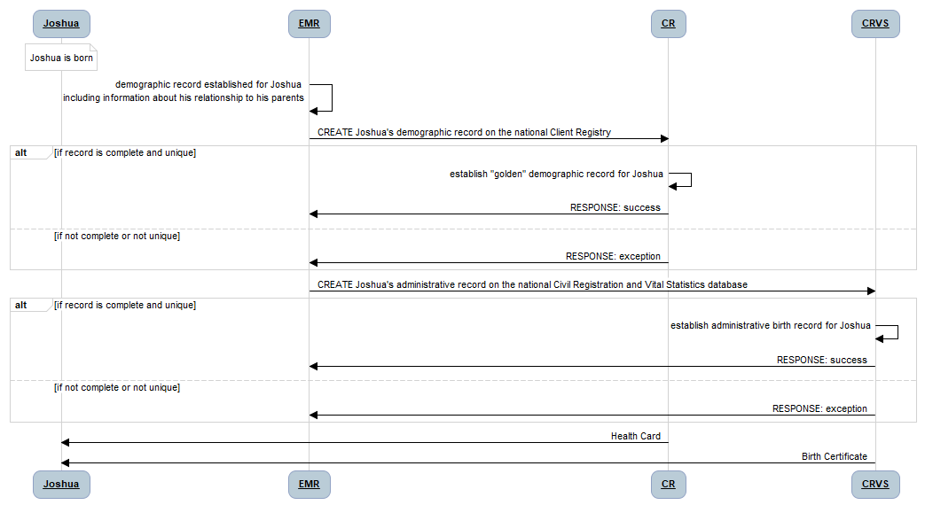

**Figure X.4.2.1-1: Process Flow for the Create Patient Use Case**

**Pre-conditions**:

Joshua is born at a care facility. The details about his name, his sex, and his parental relationships are known. These are captured in the care facility’s EMR.

**Main Flow**:

Joshua’s information in the care facility’s EMR is communicated to the MOH’s national Client Registry (CR). If the data message is complete and if Joshua’s record does not create a duplicate on the CR, the EMR receives a “success” message -- otherwise an “exception” message is returned. Joshua’s information in the care facility’s EMR is also communicated to the MOHA’s national Civil Registration and Vital Statistics (CRVS) database. If the data message is complete and if Joshua’s record does not create a duplicate on the CRVS, the EMR receives a “success” message -- otherwise an “exception” message is returned.

**Post-conditions:**

If the EMR message was complete and Joshua’s data did not create a duplicate record, his new “golden” demographic record will be established on the MOH’s CR and on the MOHA’s CRVS. In time, Joshua will receive his health card and his birth certificate.

#### X.4.2.2 Use Case #2: Update Patient Information

An existing client record is updated in a demographic database.

##### X.4.2.2.1 Update Patient Use Case Description

Following a healthy childhood and after completing his schooling, Joshua leaves home to start a new job in a nearby city. As part of starting his new job at his new company, Joshua attends at a local community clinic in the new city to obtain a physical check-up as part of the process to become enrolled in the company’s health insurance plan.

Joshua’s demographic details are updated in the clinic’s EMR to reflect his new address and his new mobile phone number. The EMR updates the MOH CR with Joshua’s updated demographic details.

##### X.4.2.2.2 Update Patient Process Flow

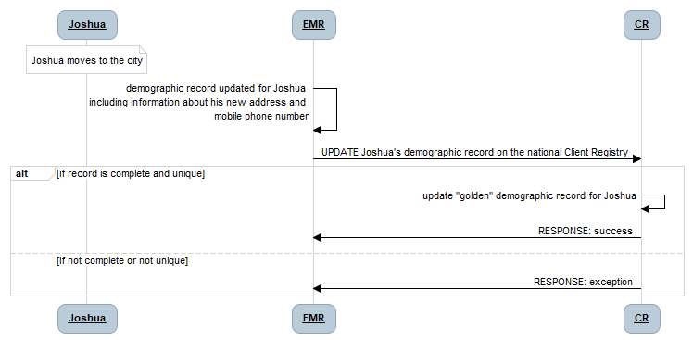

**Figure X.4.2.2-1: Process Flow for the Update Patient Use Case**

**Pre-conditions**:

Joshua has moved to the city and has a new address and mobile phone number. Joshua’s golden record is retrieved from the CR into the EMR and these updated details are captured in the community care facility’s EMR.

**Main Flow**:

Joshua’s information in the care facility’s EMR is communicated as an UPDATE to the MOH’s national Client Registry (CR). If the data message is complete and if Joshua’s record does not create a duplicate on the CR, the EMR receives a “success” message -- otherwise an “exception” message is returned.

**Post-conditions:**

If the EMR message was complete and Joshua’s data did not create a duplicate record, his existing “golden” demographic record will be update on the MOH’s CR with the new, more up-to-date information that was captured in the community clinic’s EMR.

#### X.4.2.3 Use Case #3: Merge Patient Records

A duplicate client record has been created, in error, in a demographic database. This duplicate record is merged with the pre-existing *correct* demographic record and health data that has been captured, in error, against the duplicate client ID is “re-indexed” to the correct, *surviving*, client ID.

##### X.4.2.3.1 Merge Patient Records Use Case Description

Joshua becomes concerned and travels to a different city to attend at a Voluntary Counseling and Testing (VCT) clinic to be tested for HIV. He pretends that he has forgotten his health card and provides inaccurate demographic information at the VCT, who set up a new record for him in their EMR. The EMR communicates this demographic information to the MOH’s CR where, in error, a new demographic record for Joshua is established.

Joshua completes the HIV rapid test, which is positive. A confirmatory test is taken, which has to be sent to the regional lab for processing. Both the results of the rapid test and the results of the confirmatory test reference Joshua’s **duplicate** demographic record.

When Joshua returns to the clinic to receive his confirmatory lab results, and after receiving counselling regarding confidentiality rules and the importance of care continuity, Joshua corrects his demographic information. The EMR merges Joshua’s two demographic records to a single unique ID# and sends a merge instruction to the national CR to do the same.

The various databases that store health information about Joshua have subscribed to merge transactions on the national CR. To ensure patient safety for Joshua, these systems all re-index the content they have pertaining to him so that a query using Joshua’s resolved unique ID# would, correctly, return all of the health information associated with him -- whether it was originally persisted under his duplicate ID# or under his post-merge unique ID#.

##### X.4.2.3.2 Merge Patient Process Flow

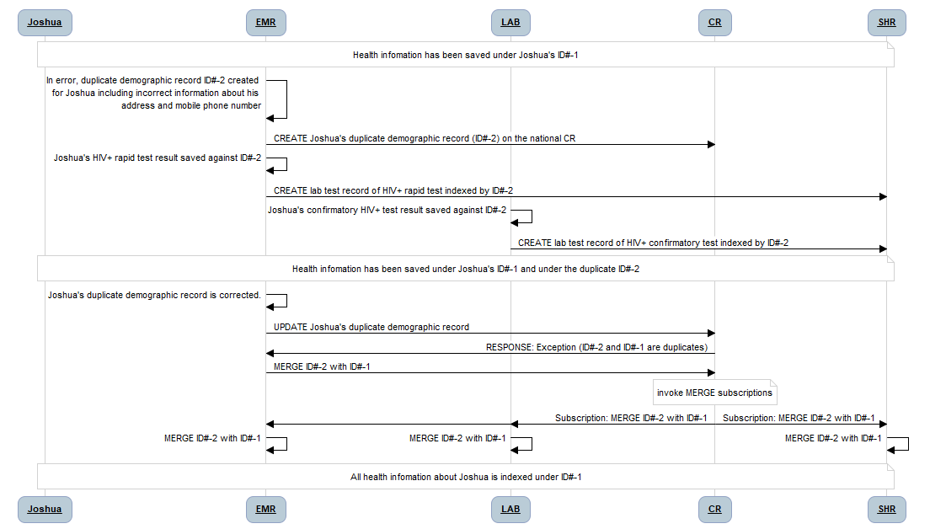

**Figure X.4.2.3-1: Process Flow for the MERGE Patient Use Case**

**Pre-conditions**:

Systems that maintain patient information subscribe to the MERGE transaction on the national Client Registry.

**Main Flow**:

A duplicate demographic record is, in error, created on the national CR. When the error is found and fixed, a transaction is executed to MERGE two demographic records on the CR. This triggers the MERGE transaction subscriptions, and health data systems that have subscribed to merges on the CR are updated with information about the ID#s that are to be merged. Each of these systems executes the transactions needed to update their local health data to reflect the MERGE transaction.

**Post-conditions:**

Following the execution of the triggered MERGE transaction, each system that maintains health data about the subject of care has re-indexed this local data to reflect the merger of the two demographic ID#s.

## X.5 <Profile Acronym> Security Considerations

*<Describe profile-specific security considerations. This should include the outcomes of a risk assessment. This likely will include profile groupings, and residual risks that need to be assigned to the product design, system administration, or policy. See the ITI document titled ‘Cookbook: Preparing the IHE Profile Security Section’ at* [*http://ihe.net/Technical_Frameworks/#IT*](http://ihe.net/Technical_Frameworks/#IT) *for suggestions on risk assessment, risk mitigation, and IT and security profiles.>*

*<If this is not a content module, delete the sentence below. If this is a content module profile, you may want to expound upon the security considerations provided by grouped actors.>*

The security considerations for a content module are dependent upon the security provisions defined by the grouped actor(s).

## X.6 PIMuF Cross Profile Considerations

*<This section is informative, not normative. It is intended to put this profile in context with other profiles. Any required groupings should have already been described above. Brief descriptions can go directly into this section; lengthy descriptions should go into an appendix. Examples of this material include ITI Cross Community Access (XCA) Grouping Rules (Section 18.2.3), the Radiology associated profiles listed at wiki.ihe.net, or ITI Volume 1 Appendix E “Cross Profile Considerations”, and the “See Also” sections Radiology Profile descriptions on the wiki such as* [*http://wiki.ihe.net/index.php/Scheduled_Workflow#See_Also*](http://wiki.ihe.net/index.php/Scheduled_Workflow#See_Also)*. If this section is left blank, add “Not applicable.” >*

*<Consider using a format such as the following:>*

<other profile acronym> - <other profile name>

A Patient Demographics Supplier in PDQm or PDQ might be grouped with a Patient Demographics Supplier to <describe benefit/what is accomplished by grouping>.

A Patient Identifier Cross-reference Manager in PIX or PIXm might be grouped with a Patient Identifier Cross-reference Manager to <describe benefit/what is accomplished by grouping>.

Functionally, it combines a PDQm Patient Demographics Supplier, a PIXm Patient Identifier Cross-reference Manager and a grouping with this profile’s own Patient Identity Source and a Patient Identity Consumer actors.

* PIXm
* PDQm
* An XDS.b registry
* MHD : the feed would go to the XDS registry for which MHD is an api.
* PAM (look at French national extension)
* V2 PIX manager query / feed
* V2 PIX manager query / feed
* QEDm

**Appendices**

*<Add appendices to Volume 1 for this profile here. Examples of an appendix include HITSP mapping to IHE Use Cases or long use case definitions.>*

*<If there are no Volume 1 appendices, enter “Not applicable” and delete the Appendix A and Appendix B placeholder sections.>*

*<Volume 1 appendices are informational only. No “SHALL” language is allowed in a Volume 1 Appendix.>*

# Appendix A – <Appendix Title>

Appendix A text.

## A.1 <Title>

Appendix A.1 text.

### A.1.1 <Title>

Appendix A.1.1 text.

# Appendix B – <Appendix Title>

Appendix B text.

## B.1 <Title>

Appendix B.1 text.

### B.1.1 <Title>

Appendix B.1.1 text.

Volume 2 – Transactions

Add Section 3.Y

## 3.Y1 Mobile Patient Identity Feed

*<The “Y” in the heading should be the same as the # in the [Domain Acronym -#] title>*

### 3.Y1.1 Scope

The Mobile Patient Identity Feed transaction sends a bundle of patient updates. A Patient Identity Source initiates a Mobile Patient Identity Feed transaction against a Patient Identity Manager. A Patient Identity Manager initiates a Mobile Patient Identity Feed against a Patient Identity Consumer.

### 3.Y1.2 Actor Roles

The roles in this transaction are defined in the following table and may be played by the actors shown here:

Table 3.Y1.2-1 Actor Roles

|  |  |
| --- | --- |
| **Role:** | Supplier: Sends a bundle of updates. |
| **Actor(s):** | The following actors may play the role of *Supplier:*  Patient Identity Source  Patient Identity Manager |
| **Role:** | Consumer: Accepts the bundle request and returns a bundle response. |
| **Actor(s):** | The following actors may play the role of *Consumer:*  Patient Identity Manager  Patient Identity Consumer  Patient Subscriber |

### 3.Y1.3 Referenced Standards

* HL7 FHIR standard Release 4 http://hl7.org/fhir/R4/index.html
* JSON – IETF RFC7159
* XML
* HTTP 1.1

### 3.Y1.4 Interaction Diagram

Mobile Patient Identity Feed Response [ITI-Y1]

Mobile Patient Identity Feed Request [ITI-Y1]

Supplier

Consumer

#### 3.Y1.4.1 Mobile Patient Identity Feed Request Message

The Mobile Patient Identity Feed message is a FHIR message with the updated Patient Resource(s).

##### 3.Y1.4.1.1 Trigger Events

A Supplier triggers a Mobile Patient Identity Feed Request to a Consumer when updates are made to the underlying patient identity data, such as link, unlink, identifier, or demographic changes.

##### 3.Y1.4.1.2 Message Semantics

A Supplier initiates a FHIR message request using HTTP POST as defined at <https://www.hl7.org/fhir/R4/messaging.html> on a Bundle Resource.

A Consumer shall support accepting a request for both the JSON and the XML messaging formats as defined in FHIR. A Supplier shall send either the JSON or the XML messaging formats as defined in FHIR. See ITI TF-2x: Appendix Z.6 for more details. A Consumer should support accepting the request using an asynchronous $process-message operation as defined at <https://www.hl7.org/fhir/R4/messageheader-operation-process-message.html>.

##### 3.Y1.4.1.2.1 FHIR Bundle Resource Constraints

The Bundle Resource shall be further constrained as described in Table 3.Y1.4.1.2.1-1. The Element column in Table 3.Y1.4.1.2.1-1 references the object model defined at <https://www.hl7.org/fhir/R4/bundle.html#resource>.

Table 3.Y1.4.1.2.1-1: Bundle Resource Constraints

| Element  &  Cardinality | Data Type |
| --- | --- |
| type [1..1] | The type shall be:  Message |
| entry [2..*] | The first resource in the entry list shall be a MessageHeader Resource.  The remaining entries shall be Patient resource(s). |

##### 3.Y1.4.1.2.2 FHIR MessageHeader Resource Constraints

A Supplier shall create a Bundle Resource of type “message” with the first entry being a MessageHeader Resource. The MessageHeader Resource shall be further constrained as described in Table 3.Y1.4.1.2.2-1. The Element column in Table 3.Y1.4.1.2.2-1 references the object model defined at <https://www.hl7.org/fhir/R4/messageheader.html#resource>.

Table 3.Y1.4.1.2.1-1: MessageHeader Resource Constraints

| Element  &  Cardinality | Data Type |
| --- | --- |
| eventCoding [1..1] | The eventCoding shall use the following:  system: urn:oid:??  code: patient-link | patient-unlink | patient-update |

See ITI TF-2x: Appendix W for informative implementation material for this transaction.

##### 3.Y1.4.1.3 Expected Actions

A Consumer shall accept the message, and return an HTTP 200 response as per <https://www.hl7.org/fhir/R4/messageheader-operation-process-message.html>.

When the message includes a link of two or more Patient resources, a Patient Identity Manager ~~that~~ ~~also responds to Mobile Patient Demographics Query [ITI-78] or Mobile Patient Identifier Cross-reference Query [ITI-83]~~ shall respond to subsequent query results with all linked Patient resources when a query is made for one of them.

Recipient shall treat linked patients as if they were the same.

When the eventCoding is patient-link, the Bundle Resource shall include at least 2 Patient Resources that are being linked with the link element populated. A Patient Identity Manager shall treat linked patients as if they were the same resource. E.g. when queries are handled on resources that reference one of the linked patients, resources that reference all linked patients will be returned.

When the eventCoding is patient-unlink, the Bundle Resource shall include at least 2 Patient Resources that are being unlinked with the link element removed.

When the eventCoding is patient-update, the Bundle Resource shall include at least 1 Patient Resource that has been updated.

#### 3.Y1.4.2 Mobile Patient Identity Feed Response

##### 3.Y1.4.2.1 Trigger Events

A Consumer sends the Mobile Patient Identity Feed Response to the Supplier when the message is accepted.

##### 3.Y1.4.2.2 Message Semantics

A Consumer responds to the Mobile Patient Identity Feed Request with an HTTP Status of 200 or an error as defined at <https://www.hl7.org/fhir/R4/messageheader-operation-process-message.html>.

##### 3.Y1.4.2.3 Expected Actions

The Supplier has received the response and continues with its workflow.

### 3.Y1.5 Security Considerations

See ITI TF-1: X.5 for security considerations for the PIMuF Profile.

See ITI TF-2x: Appendix Z.8 for common mobile security considerations.

## 3.Y2 Subscribe to Patient Updates

*<The “Y” in the heading should be the same as the # in the [Domain Acronym -#] title>*

### 3.Y2.1 Scope

The Mobile Patient Identity Feed transaction sends a bundle of patient updates. A Patient Identity Source initiates a Mobile Patient Identity Feed transaction against a Patient Identity Manager. A Patient Identity Manager initiates a Mobile Patient Identity Feed against a Patient Identity Consumer.

### 3.Y2.2 Actor Roles

Table 3.Y2.2-1: Actor Roles

|  |  |
| --- | --- |
| **Actor:** | Patient Subscriber |
| **Role:** | Sends a Subscription request to the Patient Identity Manager |
| **Actor:** | Patient Identity Manager |
| **Role:** | Accepts a Subscription request and returns where the Subscription can be accessed. |

### 3.Y2.3 Referenced Standards

* HL7 FHIR standard Release 4 http://hl7.org/fhir/R4/index.html
* JSON – IETF RFC7159
* XML
* HTTP 1.1

### 3.Y2.4 Interaction Diagram

Subscribe to Patient Updates Response [ITI-Y2]

Subscribe to Patient Updates Request [ITI-Y2]

Patient Subscriber

Patient Identity Manager

Get Patient Subscription Response [ITI-Y2]

Get Patient Subscription Request [ITI-Y2]

Update Patient Subscription Response [ITI-Y2]

Update Patient Subscription Request [ITI-Y2]

Delete Patient Subscription Response [ITI-Y2]

Delete Patient Subscription Request [ITI-Y2]

#### 3.Y2.4.1 Subscribe to Patient Updates Request Message

The Subscribe to Patient Updates message is a FHIR create operation on a Subscription Resource.

##### 3.Y2.4.1.1 Trigger Events

A Patient Subscriber triggers a Subscribe to Patient Updates Request to a Patient Identity Manager according to the business rules for the subscription. These business rules are outside the scope of this transaction.

##### 3.Y2.4.1.2 Message Semantics

A Patient Subscriber initiates a FHIR create request using HTTP POST as defined at <https://www.hl7.org/fhir/R4/http.html#create> on the Subscription Resource as defined at <https://www.hl7.org/fhir/R4/subscription.html>.

A Patient Identity Manager shall support accepting a request for both the JSON and the XML messaging formats as defined in FHIR. A Patient Subscriber shall send either the JSON or the XML messaging formats as defined in FHIR. See ITI TF-2x: Appendix Z.6 for more details.

See ITI TF-2x: Appendix W for informative implementation material for this transaction.

##### 3.Y2.4.1.2.1 FHIR Subscription Resource Constraints

A Patient Subscriber shall create a Subscription Resource. The Subscription Resource shall be further constrained as described in Table 3.Y2.4.1.2.1-1. The Element column in Table 3.Y2.4.1.2.1-1 references the object model defined at <https://www.hl7.org/fhir/R4/subscription.html#resource>.

Table 3.Y2.4.1.2.1-1: Subscription Resource Constraints

| Element  &  Cardinality | Data Type |
| --- | --- |
| channel.type [1..1] | The type shall be “message.” |
| status | The status shall be “requested.” |

##### 3.Y2.4.1.3 Expected Actions

A Patient Identity Manager shall accept the request, and return an HTTP 201 response when the Subscription is created or an error code with an OperationOutcome if an error occurs as per <https://www.hl7.org/fhir/http.html#create>. When the subscription has been set up on the Patient Identity Manager, the Subscription Resource status shall be changed to “active.” The Patient Identity Manager shall use the Mobile Patient Identity Feed [ITI-Y1] to send updates to the Patient Subscriber based on the trigger criteria defined in the Subscription Resource if the status is set to “active.”

#### 3.Y2.4.2 Subscribe to Patient Updates Response

##### 3.Y2.4.2.1 Trigger Events

A Patient Identity Manager sends the Subscribe to Patient Updates Response to the Patient Subscriber when the subscription request is accepted.

##### 3.Y2.4.2.2 Message Semantics

A Patient Identity Manager responds to the Subscribe to Patient Updates Request with an HTTP Status of 201 with the Location header set to the created Subscription Resource or an error as defined at <https://www.hl7.org/fhir/http.html#create>.

##### 3.Y2.4.2.3 Expected Actions

The Patient Subscriber has received the response and continues with its workflow.

#### 3.Y2.4.3 Get Patient Subscription Request/Response Message

A Patient Subscriber can retrieve the current details of a subscription by accessing the location returned by the Subscribe to Patient Updates Response as defined at <https://www.hl7.org/fhir/http.html#read>.

#### 3.Y2.4.4 Update Subscription [PUT] Request/Response Message

A Patient Subscriber can update the current details of a subscription by accessing the location returned by the Subscribe to Patient Updates Response as defined at <https://www.hl7.org/fhir/http.html#update>. This can be used to temporarily disable the subscription by changing the status to “off” or re-enable a subscription by changing the status to “request.” Any other details of the subscription can also be updated, and the status shall be changed to “request.” A Patient Identity Manager will suspend a subscription when the status is “off.” Any new changes with a status of “request” will be handled as per 3.Y2.4.1.3.

#### 3.Y2.4.5 Delete Subscription [DELETE] Request/Response Message

A Patient Subscriber can delete a subscription by accessing the location returned by the Subscribe to Patient Updates Response as defined at <https://www.hl7.org/fhir/http.html#delete>.

### 3.Y2.5 Security Considerations

See ITI TF-1: X.5 for security considerations for the PIMuF Profile.

See ITI TF-2x: Appendix Z.8 for common mobile security considerations.

Appendices

<Detailed cross transaction relationships or mapping details are described in an appendix in Volume 2x. Volume 2 appendices may be informational or normative. Immediately after the title of a Volume 2 appendix, provide a very explicit statement defining whether this new appendix is informative or normative.

If there are no Volume 2 appendices, enter “Not applicable” and delete the Appendix A and Appendix B placeholder sections.>

# Appendix A – <Appendix Title>

Appendix A text.

## A.1 <Title>

Appendix A.1 text.

### A.1.1 <Title>

Appendix A.1.1 text.

# Appendix B – <Appendix Title>

Appendix B text.

## B.1 <Title>

Appendix B.1 text.

### B.1.1 <Title>

Appendix B.1.1 text.